**Lab 3**

Q1.  
  
def multiply_all_numbers(list):

m=1

for i in list:

if i == 0:

return 0

m = m * i

return m

n=int(input("Enter number of elements:"))

list = []

for i in range(n):

list.append(int(input("Enter element:")))

print("Multiplication:",multiply_all_numbers(list))  
  
  
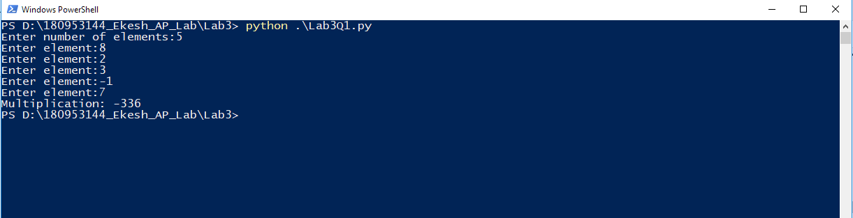  
  
Sample Input Output :  
Enter number of elements:5

Enter element:8

Enter element:2

Enter element:3

Enter element:-1

Enter element:7

Multiplication: -336  
  
  
Q2.   
  
def unique(list):

uniquelist = []

for i in list:

if i not in uniquelist:

uniquelist.append(i)

return uniquelist

n = int(input("Enter the number of elements : "))

list = []

for i in range(n):

list.append(int(input("Enter element : ")))

print("List of unique elements")

print(unique(list))  
  
  
  
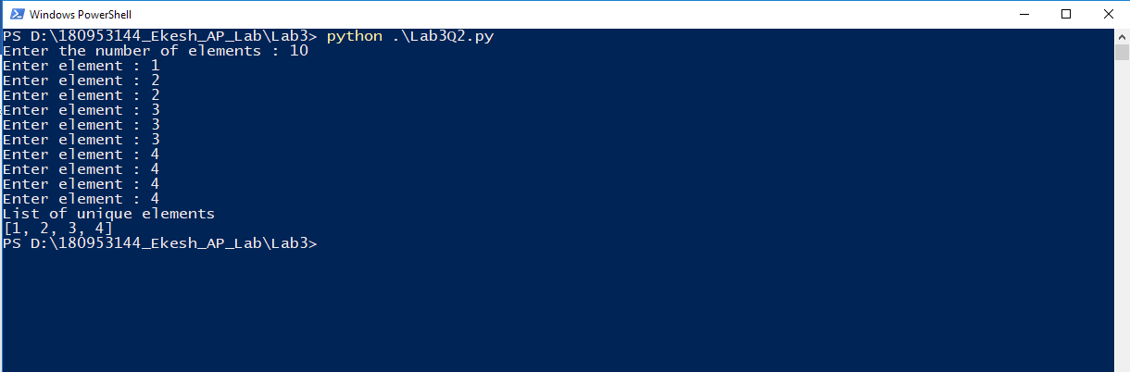  
  
SAMPLE INPUT OUTPUT:  
  
Enter the number of elements : 10

Enter element : 1

Enter element : 2

Enter element : 2

Enter element : 3

Enter element : 3

Enter element : 3

Enter element : 4

Enter element : 4

Enter element : 4

Enter element : 4

List of unique elements

[1, 2, 3, 4]  
  
  
  
  
**Lab 4**

Q1.

import math

n = float(input("Enter the number :"))

print("The sin value of the number is: " + str(math.sin(n)))

print("The square root of the number is: " + str(math.sqrt(n)))

print("The log of the given number is: " + str(math.log(n)))  
  
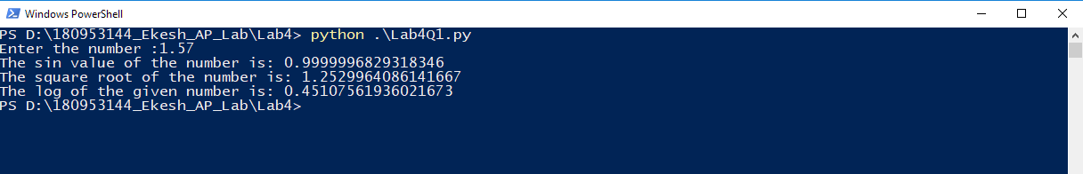  
  
  
Q2.  
  
import cmath

n = complex(input("Enter the number :"))

print("The sin value of the number is: " + str(cmath.sin(n)))

print("The square root of the number is: " + str(cmath.sqrt(n)))

print("The log of the given number is: " + str(cmath.log(n)))  
  
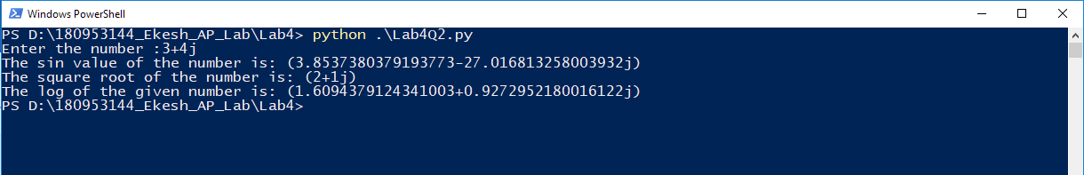

Q3.

import os

print(os.environ)

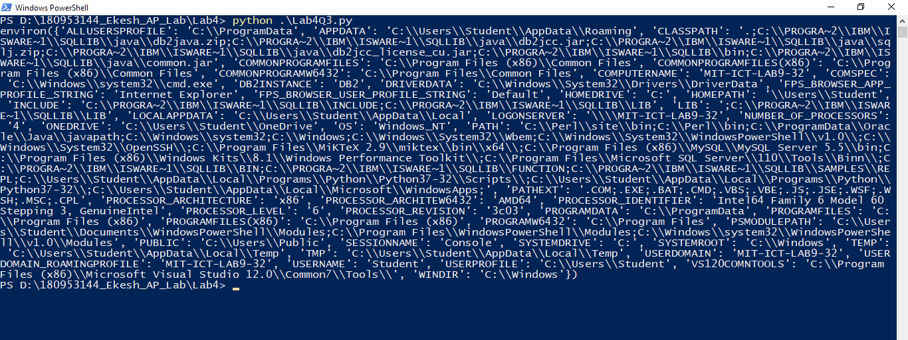

**Lab 5**

Q1.